

# PROJECT:. Clothes shop GROUP NO: . 08 . . . ., BATCH: . . . .T1.2011.E1 . . . . . . .

1. **Software and Hardware Requirement**
2. **Hardware requirement**

|  |  |
| --- | --- |
| **Component** | **Requirement** |
| **Server** | Processor type:  Pentium III-compatible processor or faster  Processor speed:  Recommended: 2.0 GHz or faster |
| **OS** | Microsoft Windows Server 2003 or higher |
| **Memory (RAM)** | RAM:  Minimum: 512 MB  Recommended: 2.0 GB or more  Maximum: Operating system maximum |
| **Hard Drive** | Free space:  Minimum: 50 MB  Recommended: 50 GB or more  Maximum: Operating system maximum |

1. **Software requirement**

|  |  |
| --- | --- |
| **Component** | **Requirement** |
| **Java Development Kit** | Version 1.8.x |
| **NetBeans** | 8.2 |
| **RDBMS** | Microsoft SQL Server 2012 or higher |
| **Hosting** | Glassfish 4.2 |
| **Web Browser** | Chrome (recommended), Firefox, IE 7 or higher |

1. **CONFIGURATION**

* After you have downloaded our project file, please extract it. There are 5 sub-folders inside the folder:

+ **“Database” folder:** storing **query script for the database**.

+ **“Source code” folder:** where the **package** for the application is stored.

+ **“Document”** where the **eProject report, feedback, user guide and the installation guide** in document format are stored. These file have a copy in PDF format in root.

**Please read the installation guide and then the user guide before running our application.**

1. **Database Configuration**

**Step 1**: Open **Microsoft SQL Server Management Studio** and the **Connect to Server** window opens. If not, you can open it manually by selecting **Object Explorer** > **Connect** > **Database Engine**.

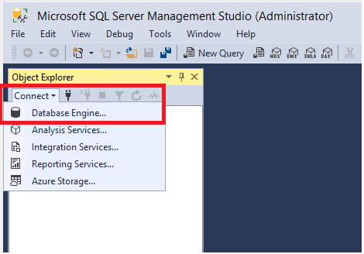

**Step 2**: In the **Connect to Server** window, do the following:

* **For Server name**, enter the name of your SQL Server (it would be filled normally).
* **For Authentication**, select **SQL Server Authentication**
* **For User Name**, enter your user name
* **For Password**, enter your password
* After you've completed all the fields, select **Connect.**

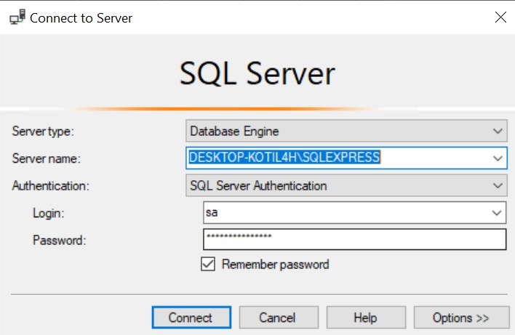

**Step 3**: Go to the **Database** folder, find and open (double click) the SQL-Query file – **“Database.sql”**

**Step 4:** This file will automatically open in the **Microsoft SQL Server Management Studio**. Then please click on **Execute button** on the top Menu bar (If this button is not available, please click on blank space of the query document).

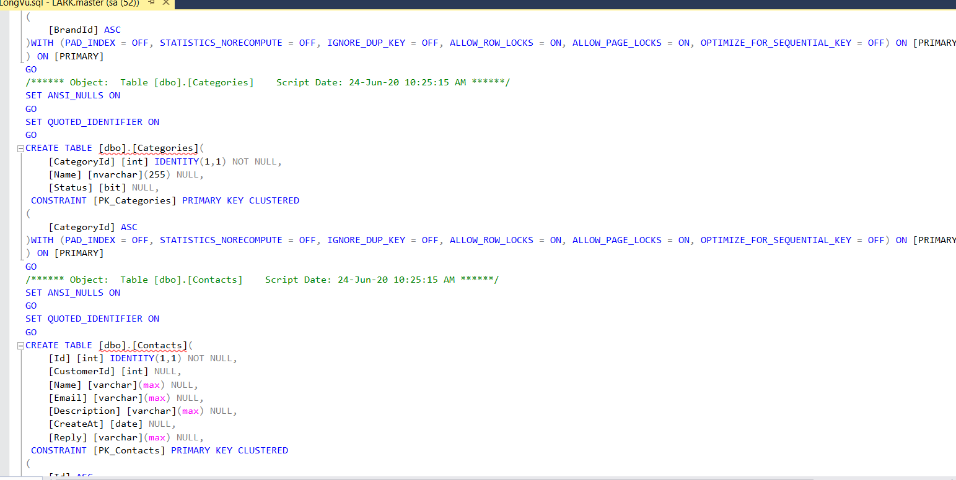

**Step 5**: After the script is executed successfully, right-click on **Database** and select **Refresh**. You can see the database named **ThunderShop** appears in **Object Explorer**.

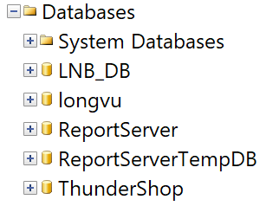

1. **Project Configuration**

If glassfish4 is not installed please go to this page to download and install it.  
<https://javaee.github.io/glassfish/download>

**Step 1**:   
You can download glassfish 4.2 on google or can be found in Enima / web / libs in the project

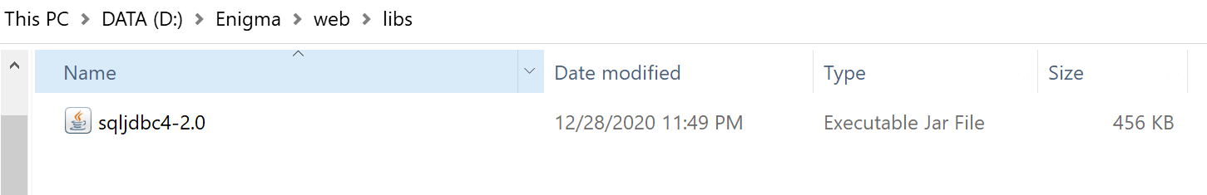

**Step 2:** Open the project and select Services and new connection> select the path to the downloaded jdpc file.  
 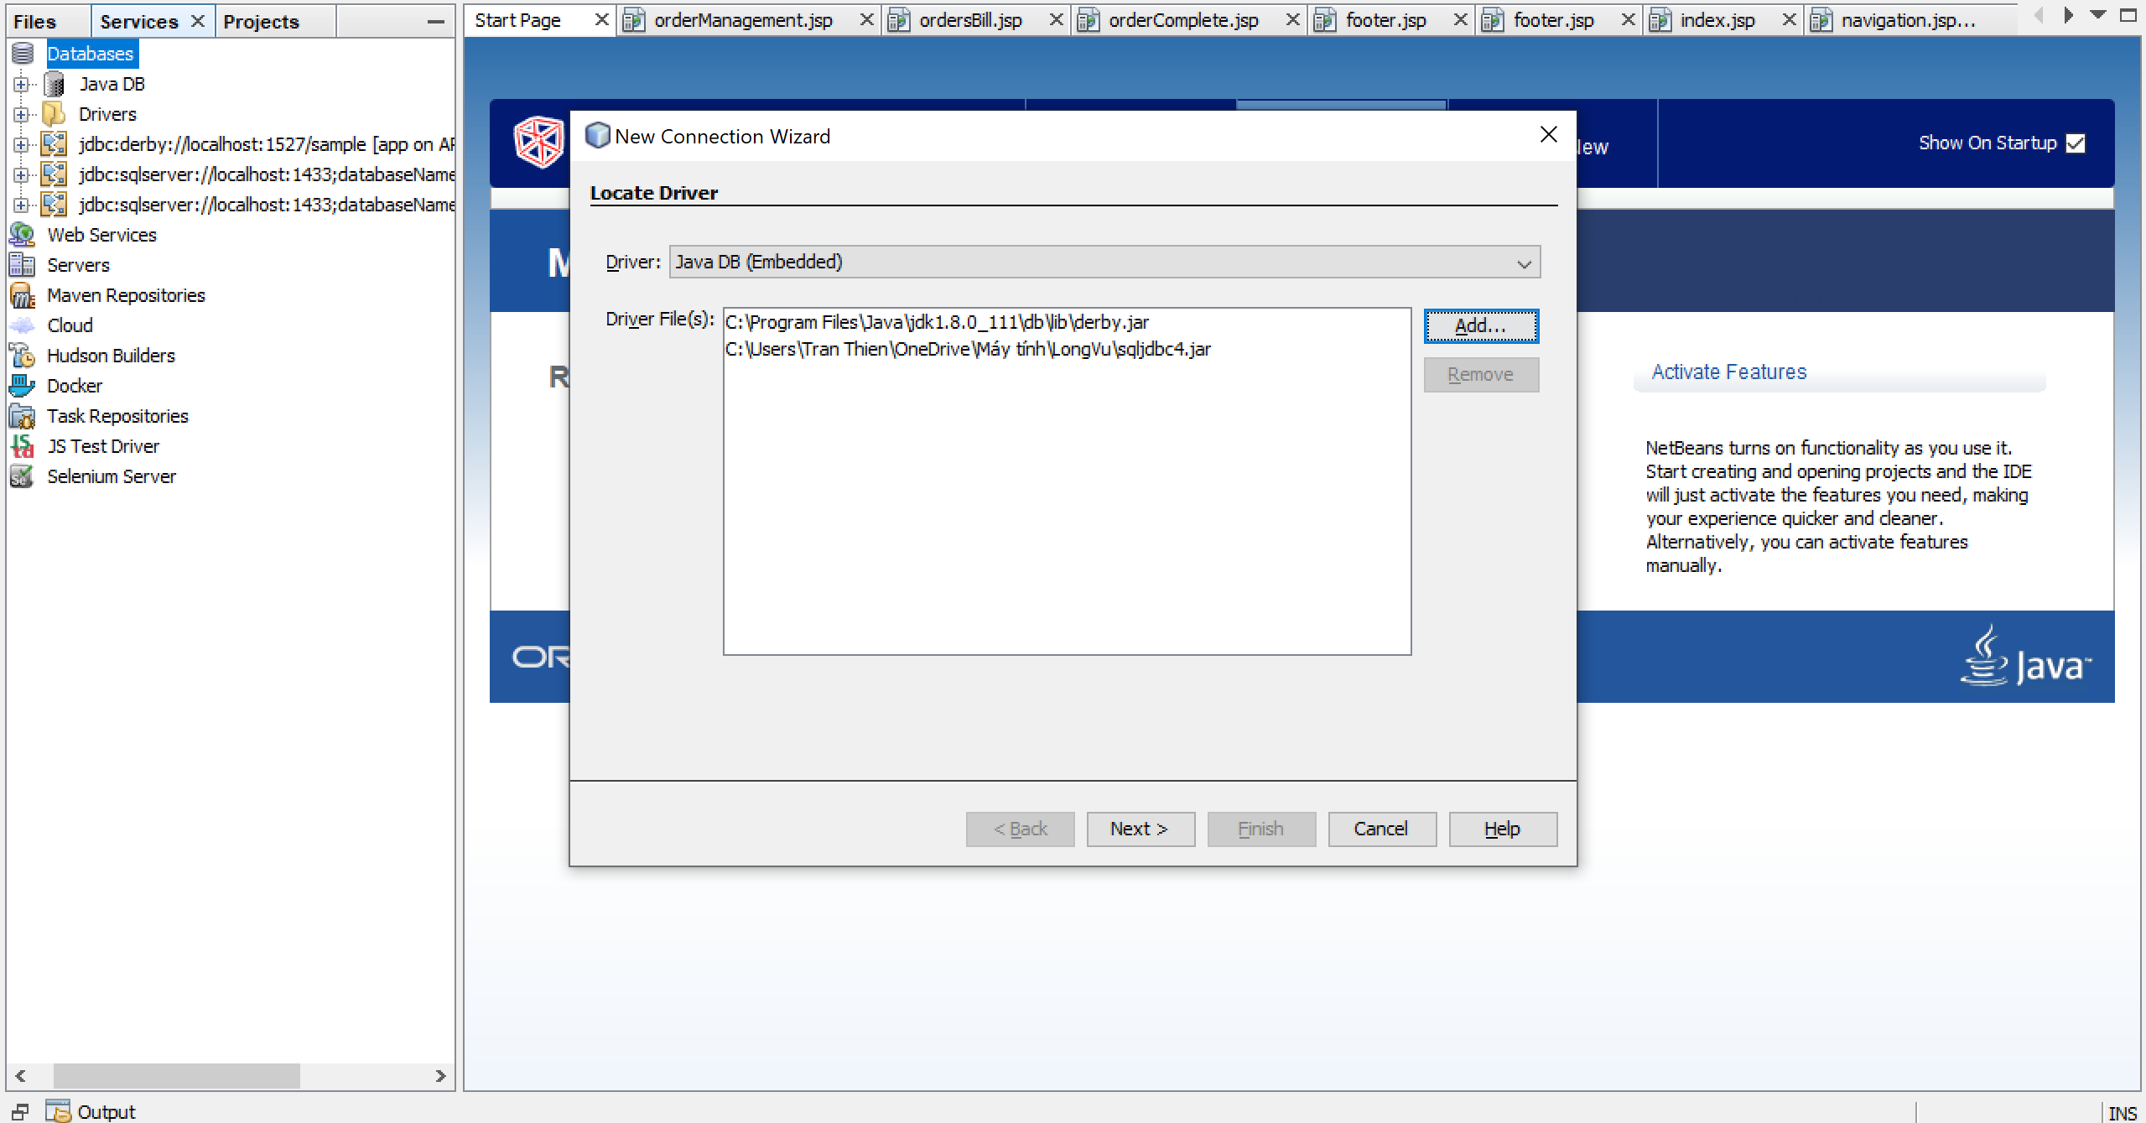

**Step 3:**   
Add the connection string database

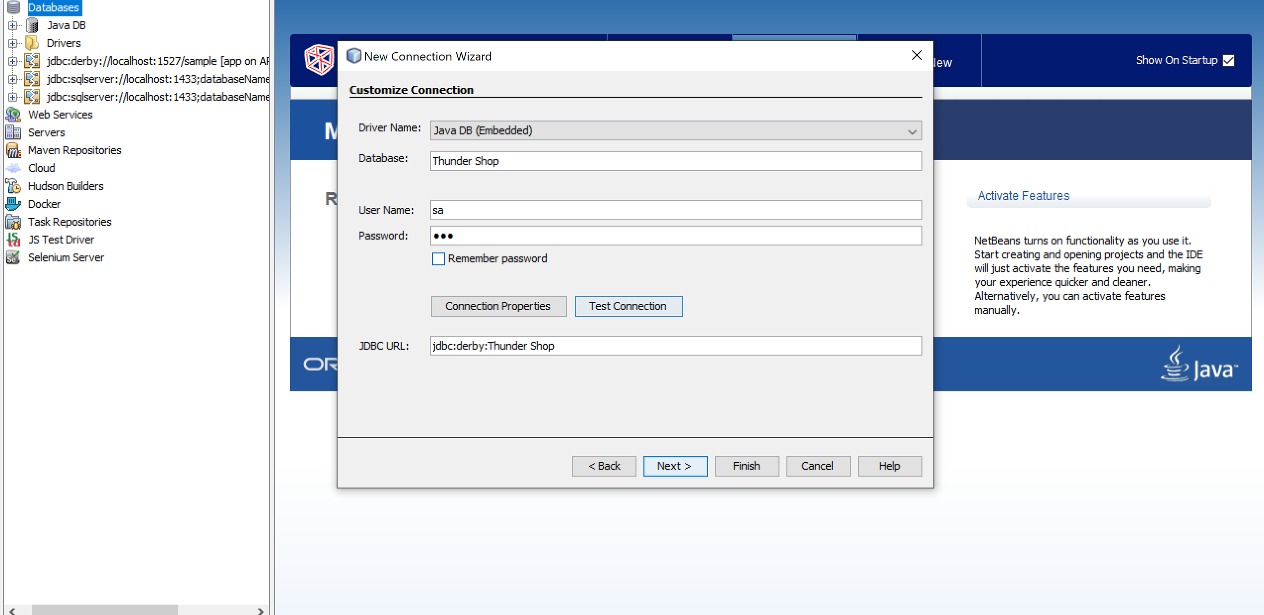

**Step 4:**   
Successful connection will receive the following file

